**NARRATIVE PROGRESS REPORT**

|  |  |
| --- | --- |
| **Organization submitting the Report** | UNION DE SOLIDARITE D’AIDE AU DEVELOPPEMENT COMMUNAUTAIRE (USADEC) |
| **Name and title of the contact person** | MAHORO RUBIBI Alexis ;Executive Director |
| **Project Title** | Strengthening Civic participation in the prevention and resolution of family conflict in BUGARAMA Sector |
| **Reporting Period** | March –July 2024 |
| **Project Location** | RUSIZI i District ,BUGARAMA Sector |
| **Submitted to** | Never Again Rwanda |
| **Contact details** | **Phone: +250 788642109**  **E-mail :usadec19@gmail.com** |
| **Date of report submission** | **July 10 ,,2024** |

# **EXECUTIVE SUMMARY**

The project of Strengthening civic participation in the prevention and resolution of family conflict meet with 12th resolution of the 18th National Dialogue Council - Umushyikirano and focuses on building strong and secure families . The project is implementing in BUGARAMA Sector ,RUSIZI District from March to July 2024 by USADEC in partnership with Never Again Rwanda .

The mainobjective of the project is contributing in building strong and secure families with focus on preventing and resolving family conflicts

The specific objectives are

* To strengthen stakeholders including local authorities, FBO leaders and community in challenging causes of conflicts and family violence that prevail in the project area
* To enhance and contribute to conflict prevention and resolution engaging women, men, youth and other members of the community through media campaigns and dialogues.
* To contribute to the reduction and mitigation of family conflicts through mutual and peaceful conflict resolution measures and social support

The final reporting period covers the project activities implemented during the first and second instalment of the project from March to July 2024 specifically

**1 - introduction of the project to local authorities and stakeholders** at BUGARAMA sector and RUSIZI District level to justify the context, relevance and objectives of the project, the role of all and everyone in the project implementation , monitoring and evaluation;

**2- Conduct KAP baseline survey of 3 days** to carry out an assessment on the existence of family conflicts and Knowledge attitude, and practice from 45 persons about conflict prevention and resolution within the project beneficiaries from 3 cells of BUGARAMA sector to analyse the current situation on family conflicts which prevails in the project area.

KAP baseline survey has documented the current situation with a tangible number of conflict cases to be resolved.

**3- Organisation of 2 stakeholders meetings**

The 2 days meeting has involved 15 Stakeholders including *Village chefs , Cell executives , youth leader ,Executive Secretary of sector, , Community mediation and* conﬂict *resolution committees ,religious leaders)* selected from BUGARAMA Sector to inform them from the baseline survey results and peace building processes to support behaviour change initiatives and advocacy for change in families, Thus a joint action has been developed and validated aiming at enhancing family conflict prevention and resolution and setting up strategies for its dissemination .

**4- Development of a Training manual/guide**

To prepare a training of trainees a simplified training manual with information to address and change mind set among families about domestic conflicts has been developed .

This manual has been used during and after the training to guide the trainees who serving agents of change in facilitating community dialogues with peers. This manual focus on conflict prevention and resolution and helps the trainees to facilitate conflict prevention and resolution initiatives and mobilize community members

**5- Organisation of training of 12 trainers on family conflict prevention resolution**

The training of 2 days has gathered 12 trainees in BUGARAMA sector (6 women, 3 men, 3 people with disabilities). The training covered the topics on family conflict prevention, management and resolution.

6-**Organize community dialogue on conflict prevention and resolution in 3 cells.**

This activity is performed in terms of debates whereby 2 peace clubs encounter with themes focusing on conflict prevention and resolution in 3 cells. This activity gathers a large number of people approximately 120 per cell during UMUGANDA, UMUGOROBA W’UMURYANGO, and INTEKO Z’ABATURAGE. And it creates platform for speaking out on violence, gender equality. Women need to be trusted and be engaged in decision making processes and given some level of trust after being empowered. This is why USADEC believes that women need conflict management strategies and skills to be responsible citizens since it will reduce family stress and tensions as well as create peace environment for the society.

**7-Media campaign**

USADEC works in 3 villages in three cells of Bugarama sector but its ambitious goal is to reach out to many villages, cells and sectors all over the Rusizi district, which is the reason why media is the best way to get to those we can’t reach out to directly.This activity consists of disseminating the message of family conflict prevention and resolution on radio talk shows. The first alternative used is to choose 2 to 5 people to go to radio stations (Community Radio Rwanda or African FM Radio) with a journalist and address followers on different topics of family conflict prevention and resolution, then share their success stories to inspire others.

If the budget does not allow the above activity, we plan to apply another alternative of inviting a journalist on the field to record beneficiaries success stories then broadcast and rebroadcast the talk show twice a month on the radio. The main purpose of this activity is to reach out to a bigger number through family’s testimonies as we believe that over 6000 thousands of people listen to the Country FM radio and we make sure that it is rebroadcasted to get those who missed the show the first time. It contributes to attracting potential donors as well, as the performed activities are posted on USADEC website and are recorded on CDs to be given to each and every peace club and it is tangible evidence to the impact the project is making

**8- Support the poor families in income generating activities.**

The rabits/hens will be distributed to 30 vulnerable families who are the direct beneficiaries of this project. To ensure good growth, better productivity and the fight against diseases of rabits/hens, kits of veterinary products (medicines, vaccines) will be purchased and distributed to 30 vulnerable families. The distribution of rabits/hens will be done by the USADEC staff in collaboration with the grassroots local authorities, including the executive secretaries of the cells as well as the village committees.

**DESCRIPTION OF ACHIEVED OUTCOMES**

The progress achieved against planned project outcomes are described as follows

**Outcome 1**: **The project results and lessons learnt are properly collected, analysed and documented**

The KAP baseline survey report contributed to highlighting the current situation of family conflicts which prevails in BUGARAMA sector. The key causes and consequences resulting from family conflicts are identified , Number of households living in domestic conflict are targeted at village and cell level (3-5 families in each village in average ) and the strategies to be taken and interventions to be carried out are agreed with stakeholders to deal with them. This will allow to assess the relevance and efficiency of the project implementation and the management and effectiveness of the project objectives and results, as well as to identify potential prospects for sustainability and recommendations to promote the Project’s results at the end of the project

**Outcome 2:** **Increased ownership and participation of stakeholders in the prevention and resolution of family conflicts processes**

The introduction of the project to the local authorities of RUSIZI district and BUGARAMA sector and stakeholders allowed them to understand the relevance of the project to take ownership of the project and to commit to actively participating in the execution and monitoring and evaluation for achieving its objective

The presentation of the KAP baseline survey reports to local authorities and stakeholders and their information on the current situation of family conflicts which prevails in BUGARAMA Sector ; causes and consequences of family conflicts are identified, ,number of cases of families living in conflicts are targeted this allowed stakeholders to become more involved in the prevention and resolution of conflicts family conflicts . Thus local authorities and stakeholders attending the 2 days meeting have developed and validated a joint action plan aiming at the prevention and resolution of family conflicts and they committed to implementing this action plan which will be evaluated at the end of July 2024 . The local authorities and stakeholders are also committed to integrating into their interventions the prevention and resolution of family conflicts with active participation of the community They also engaged to strengthening the civic participation in the prevention and resolution of family conflicts through existing mechanisms such as UMUGANDA, UMUGOROBA W'UMURYANGO, INTEKO Y'ABATURAGE at village level.

**Outcome 3:** **The 12 trainers of peace increased their knowledge and facilitate trainings on family conflict prevention and resolution**

The 12 trainers of trainees have certificates and sufficient Knowledge and ability to solve family conflicts in an effective way. Trained participants are become focal points in their villages to facilitate the rest of the group that didn’t get the opportunity to attend the training and are able to conduct community dialogues on family conflict prevention and resolution in their respective communities/villages through UMUGANDA, UMUGOROBA W’UMURYANGO, INTEKO Z’ABATURAGE The trainers of trainees have guide manual focused on conflict prevention and resolution to use after the training to facilitate them to conduct community dialogues and undertake to facilitate conflict prevention and resolution initiatives and mobilization .

**Outcome 4**: **Increased knowledge of the community on family conflict prevention and resolution.**

As part of increasing the knowledge and skills of the community on the prevention and resolution of family conflicts, the community dialogues were organized for this purpose and brought together the population of 3 cells of BUGARAMA sector (PERA, NYANGE and RYANKANA cells)

The community dialogue took place at the big player ground of RYANKANA cell on July 3, 2024. Thus the population, local authorities at village cells, and sector, level religious leaders, coordinator of Never Again Rwanda in RUSIZI district as well as families in conflict all were present

The community dialogue was facilitated by Agnes NYIRANGIRIMANA in collaboration with previously trained community facilitators

Local population has been sufficiently informed about the causes of family conflicts and the consequences that result from them. Thus, in collaboration with local authorities and stakeholders, they have committed to actively participating in the prevention and resolution of family conflicts through the delivery of the information in time and, mediate families in conflict

**Outcome 5: The socio-economic conditions of vulnerable families in domestic conflicts are improved (incomes increased and healing of hearts**). Vulnerable families at high risk of family conflicts and those victims of family conflicts as well as community leaders benefited from farmed rabbits and basic veterinary products to increase income.

It was noted that poverty is both a key factor in family conflict and that family conflict causes poverty.

Rabbit breeding was chosen for the following reasons:

It constitutes an income-generating activity

the rabbit is an early breeding species which does not require large investments in terms of feeding, vaccination and treatment of animal pathologies

rabbit meat is highly appreciated by consumers and the related market is assured

Rabbit manure is very effective in improving soil productivity and increasing agricultural production

**PROGRESS AGAINST PLANNED ACTIVITIES**

The activities implemented in the first milestone (March-April 2024) focused on KAP Baseline Survey, 2 days Meetings with stakeholders ,Development of Module guide for training and effective training . Below is the detailed description of the activities implemented in the first milestone of the project

**Activity 1: Conduct KAP Baseline survey in BUGARAMA sector**

In line with the project objectives, USADEC has carry out an assessment on the existence of family conflicts by KAP (Knowledge, attitude, and practice) about conflict prevention and resolution within the project beneficiaries from 3 cells of BUGARAMA sector. Such as NYANGE,PERA and RYANKANA .The activity has conducted par 3 staffs of USADEC namely MAHORO RUBIBI Alexis (Executive Director), RUBAYIZA Jean Baptiste (project field officer) and NYIRANGIRIMANA Agnes (Monitoring and Evaluation officer)

The objective of this activityis to conduct a 3 days rapid survey from 45 persons with 24 men and 21 women including stakeholders local authorities. The information from this baseline has been shared with local leaders and stakeholders for peace building processes . This help to support behaviour change initiatives and advocacy for change in families. The data collection has been conducted in March 22,25 and 26,2024 and focused on a Questionnaire

The target Groupsampled includes Executive secretary of cells/ SEDO, Villages coordinators /security in charge at village level, IZU, CNF, CNJ ,Mediator ,and persons from families living in domestic conflict .

The key findings from baseline survey are :

* **Cases of family conflict:** the majority of participants indicated that at least in the village they can easily identify 3 to 5 cases of acute family conflict in average.
* **Attitudes and practices characterizing family conflict**: Infidelity between spouses, poor management of domestic economic resources, disputes and fights, confrontation and aggression, between spouses and children, alcoholism and drunkenness, consumption of drugs ,expulsion
* **Causes of family conflict:** drunkenness/alcoholism, infidelity between spouses, inequality in the management of domestic economic resources, lack of responsibility, lack of respect between spouses, poor interpretation and understanding of the concept Gender equality and gender equity, poverty
* **Consequences of family conflict :** Child delinquency, children dropping out of : school, poverty, child malnutrition, killings and between spouses, suicide, depreciation , conception of early pregnancies among young girls and drug use among boys
* **Strategies for preventing family conflict**:, capacity building (training), sensitization and community mobilization, heavy sanctions for actors of domestic violence, providing information in time to denounce families in conflict, socio-economic support for vulnerable households at high risk of family conflicts community ownership and commitment in the prevention and resolution of family conflicts
* **Strategies for eliminating family conflicts**: close Community education on family conflict, preservation of laws governing the cohabitation of spouses, socio-economic support for households
* **Actors in the process of family** conflict prevention and resolution: family members (husbands, wives, children), local authorities of isibo, village and cell, opinion leaders, security institutions/police, RIB, organization of religious society, CSOs , entire community

**Photos of participants in KAP Baseline Survey**

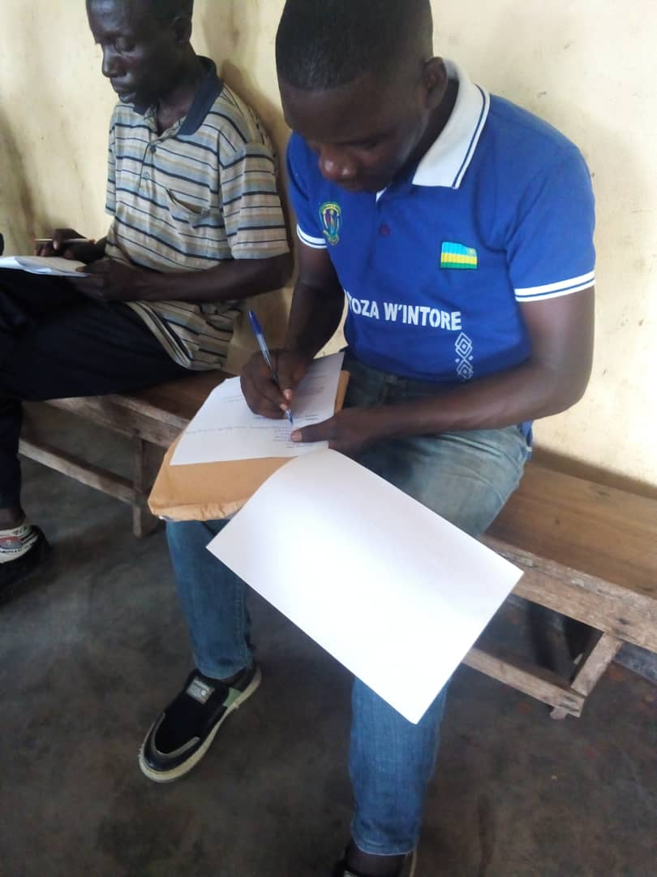 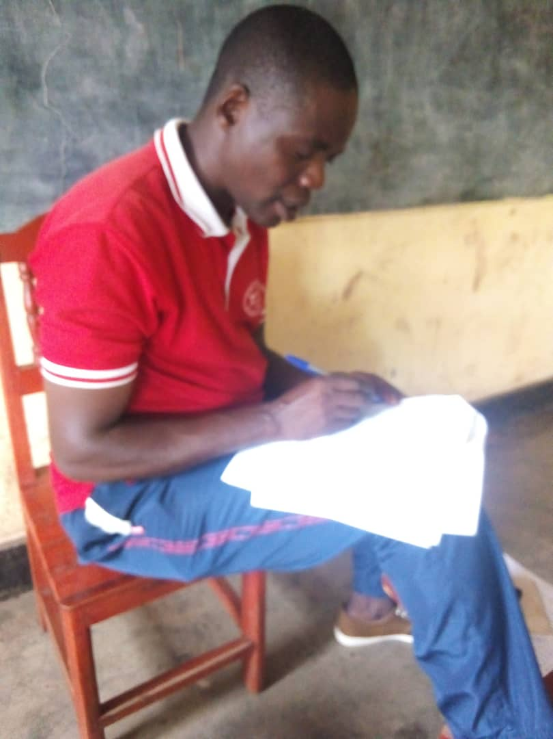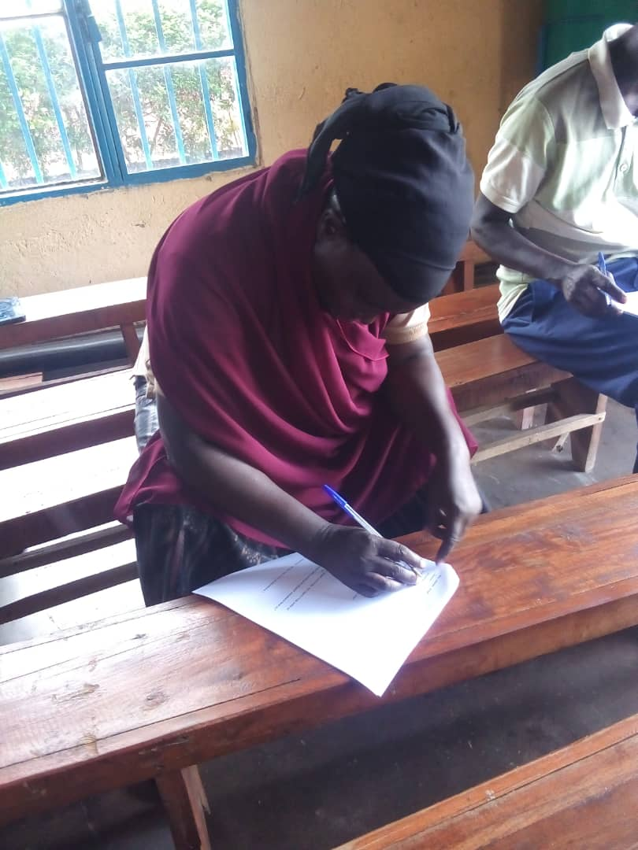

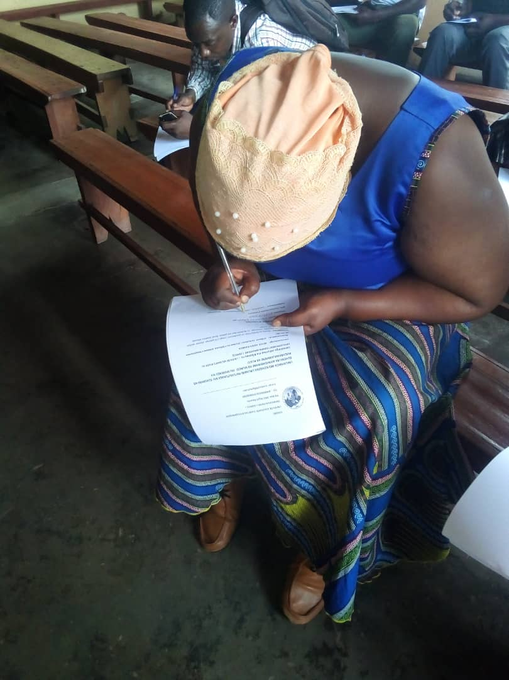 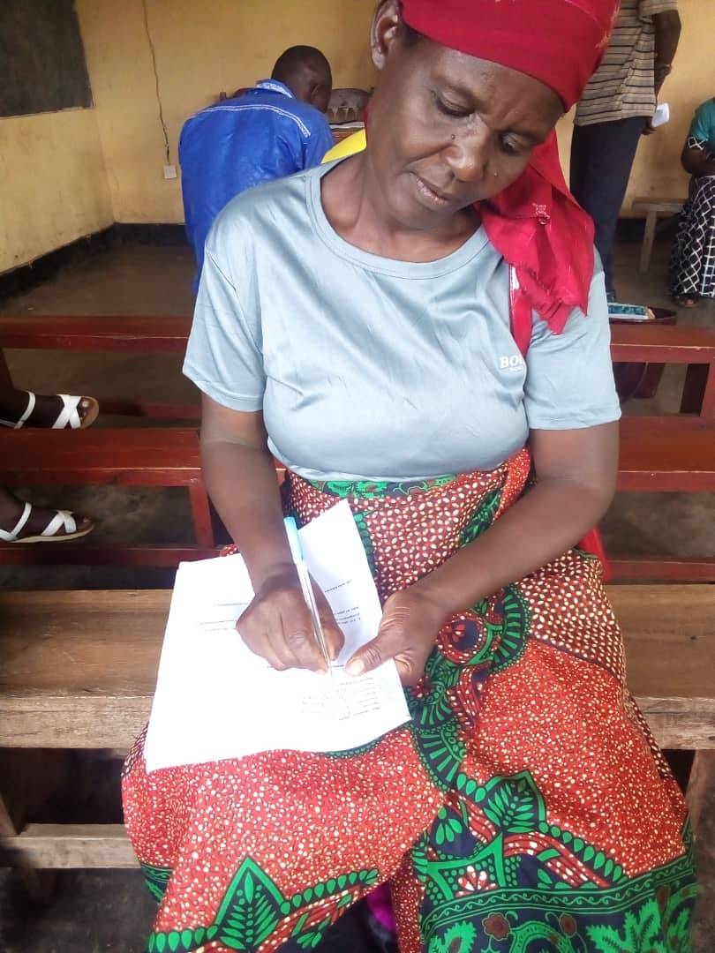

**Activity 2: Organizing meeting with stakeholders**

The activity has been executed in 2 days from 27 to March ,28 ,2024 in BUGARAMA sector and gathering 15 stakeholders with 9 Male and 6 .female including Executive Secretary (1) of sector, 3 cells Executives secretary 3 villages coordinator ,religious leader(2),CNF(1) ,youth leader (1) ,CNDP,(1) mediation and conflicts resolution committees (3) The meeting has been facilitated by MAHORO RUBIBI Alexis Executive Director of USADEC in collaboration with RUBAYIZA Jean Baptiste Project Field Officer .The objective of Activity was to present KAP baseline survey reports to stakeholders and their information on the current situation of family conflicts which prevails in the project area , causes and consequences of family conflicts identified, ,number of cases of families living in conflicts targeted .Thus stakeholders are committed to become more involved in the prevention and resolution of conflicts family conflicts .

The stakeholders attending the 2 days meeting have developed and validated a joint action plan aiming at the prevention and resolution of family conflicts and they committed to implementing this action plan which will be evaluated at the end of July 2024 . The local authorities and stakeholders are also committed to integrating into their interventions the prevention and resolution of family conflicts with active participation of the community They also engaged to strengthening the civic participation in the prevention and resolution of family conflicts through existing mechanisms such as UMUGANDA, UMUGOROBA W'UMURYANGO, INTEKO Y'ABATURAGE at village level.

**The photos reflecting the implementation of the meeting with stakeholders to present KAP survey report**

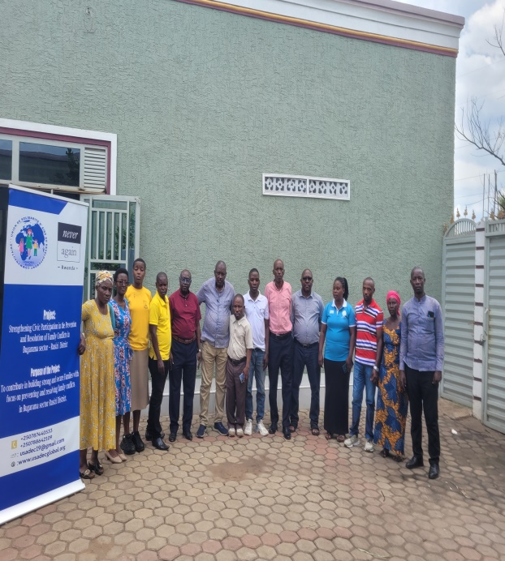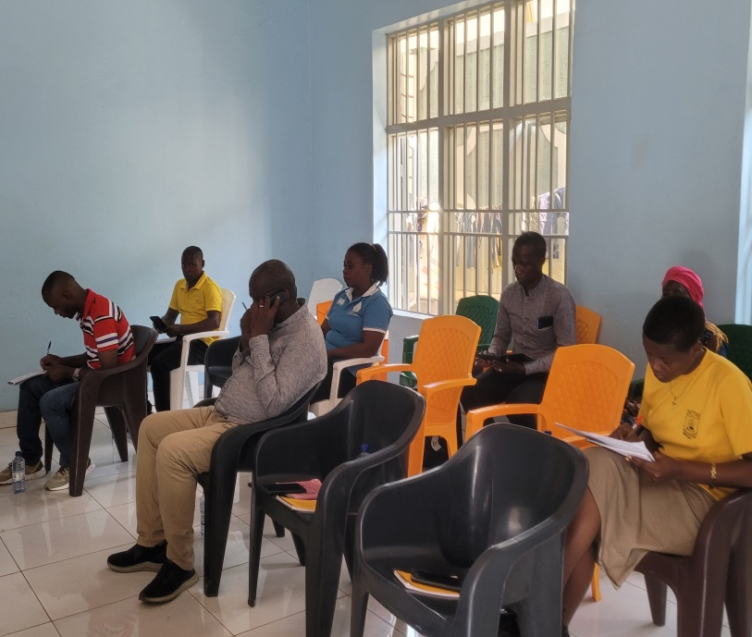

**Activity 3: Validation of Module guide for training**

The validation of Module guide for training has been organized at BUGARAMA sector onMarch28.2024 (one day) and gathered 15 participants composed by local authorities , stakeholders and potentials trainees including 9 men and 6 women and was consisted to update the content of training module .The activity has facilitated by the External consultant in collaboration with Executive Director of USADEC and Project Field Officer

**Photos of participants in the activity of module guide validation**

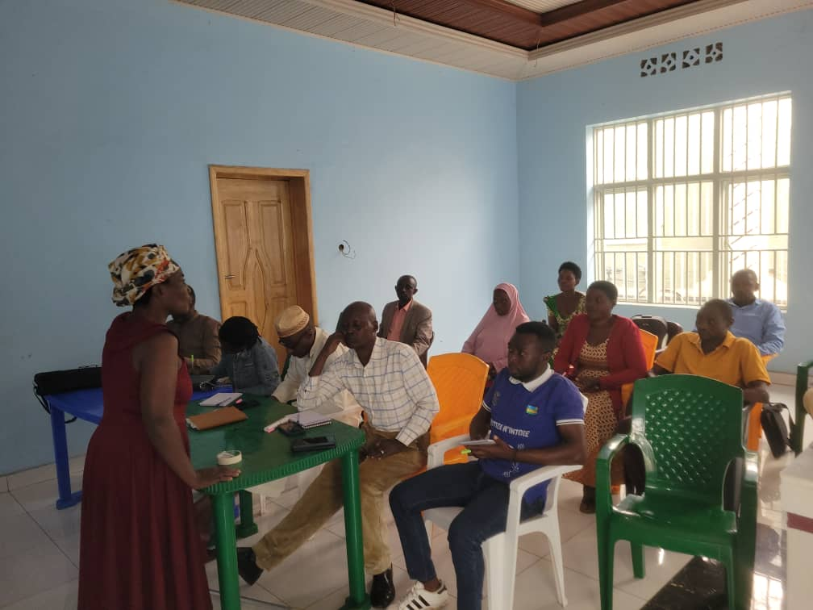 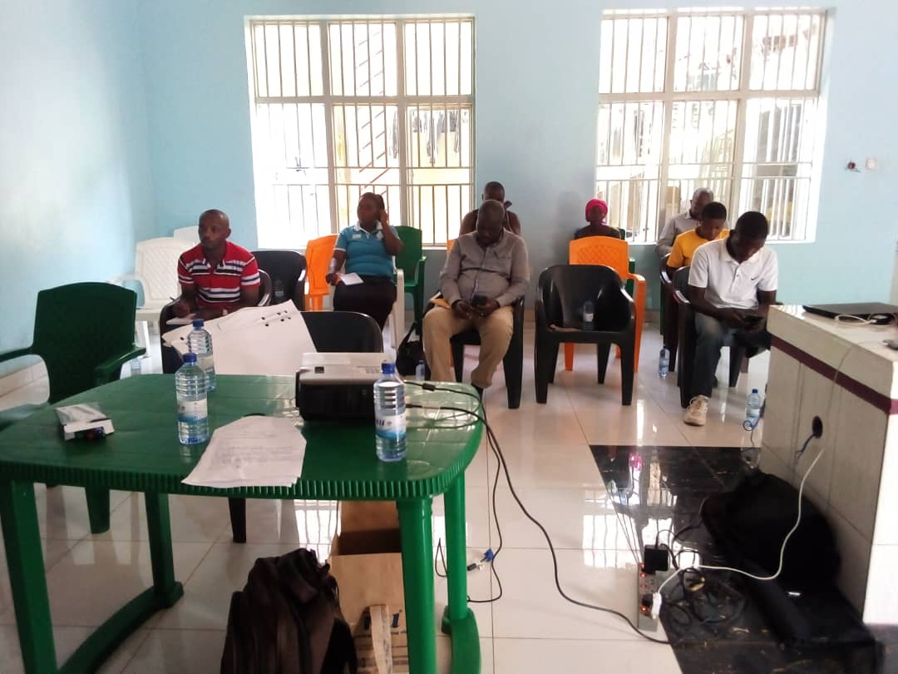

**Activity 3: Capacity Building (training workshop)**

The training took place on 2- 3/2024 and brought together 12 participants including 6 women 3 men and 3 people living with disabilities due to 4 participants from each cell of BUGARAMA Sector. The training focused on conflict prevention and resolution and was facilitated by an external consultant Fred Musiime

The applied methodology focused on the training techniques of adults persons such as active brain storming, round table, question- answer, group work and plenary presentation, and homework The training materials were note books, pens, scotch , markers and , projector

**Training schedule**

**Day 1**: arrival and registration of participants, opening of the training by Executive Director of USADEC and Executive Secretary of BUGARAMA Sector,, agree on the training program , setting up the instructions and working rules, comparison of the expectations of the participants at content of the training.

**The first day the training** covered the following content

-Definition of conflict, prevention and Resolution

-Domestic violence

-Types of conflicts

-causes and consequences of family conflicts

-behaviour and practices toward family conflict

-Group work and presentation

The first training session started at 9am and ended at 3 p.m.

**The 2nd day of training focused** on the evaluation of the previous day. The content of the training were was Family conflict tree, Key tools to analyse family conflict, strategies for prevention and resolution of family conflict, ,Quality and competences of facilitator involved in conflict resolution , Development of a conjoint Action plan to be implemented by trainees as community animators after the training . At the end of the session of the training, the participants have an evaluation test followed by the final evaluation and distribution of certificates to participants In his closing speech to the training, Executive Director of USADEC in collaboration with the social affairs officer of BUGARAMA sectors all urged the participants to put into practice the concepts acquired and to proceed with community mobilization on a larger scale on prevention and resolution of family conflicts through **UMUGANDA, INTEKO Y'ABATURAGE AND UMUGOROBA W'UMURYANGO** .

**Photos** **of participants receiving certificates at the end of the training**

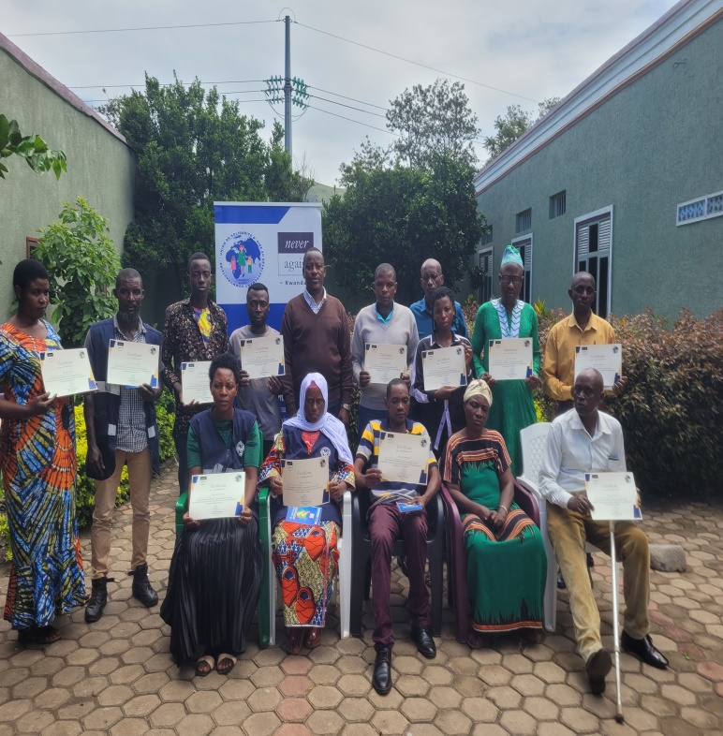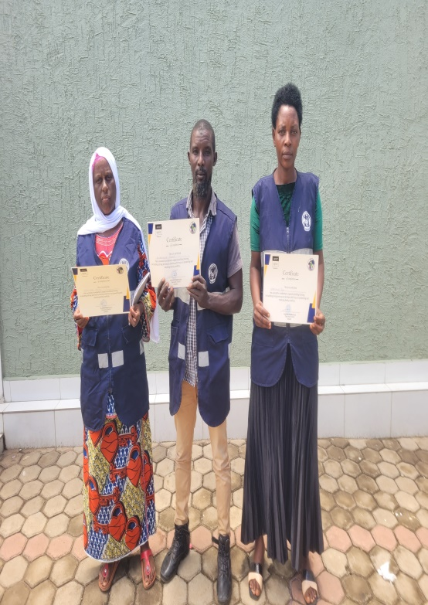

**Youth Representatives of CNJ at cell level committed to prevent family conflict**

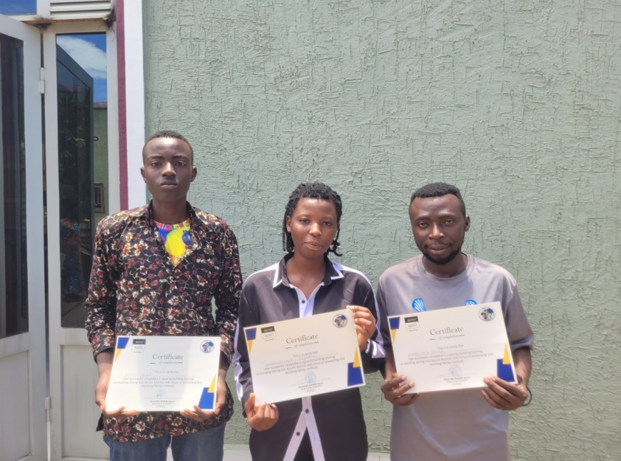

**Activity 4**: **Organize community dialogue on conflict prevention and resolution in 3 cells.**

As part of increasing the knowledge and skills of the community on the prevention and resolution of family conflicts, the community dialogues were organized for this purpose and brought together the population of 3 cells of BUGARAMA sector (PERA, NYANGE and RYANKANA cells)

The community dialogue took place at the big player ground of RYANKANA cell on July 3, 2024. Thus the population, local authorities at village cells, and sector, level religious leaders journalists , coordinator of Never Again Rwanda in RUSIZI district as well as families in conflict all were present

The community dialogue was facilitated by Agnes NYIRANGIRIMANA in collaboration with previously trained community facilitators

Local population has been sufficiently informed about the causes of family conflicts and the consequences that result from them. Thus, in collaboration with local authorities and stakeholders, they have committed to actively participating in the prevention and resolution of family conflicts through the delivery of the information in time and , mediate families in conflict

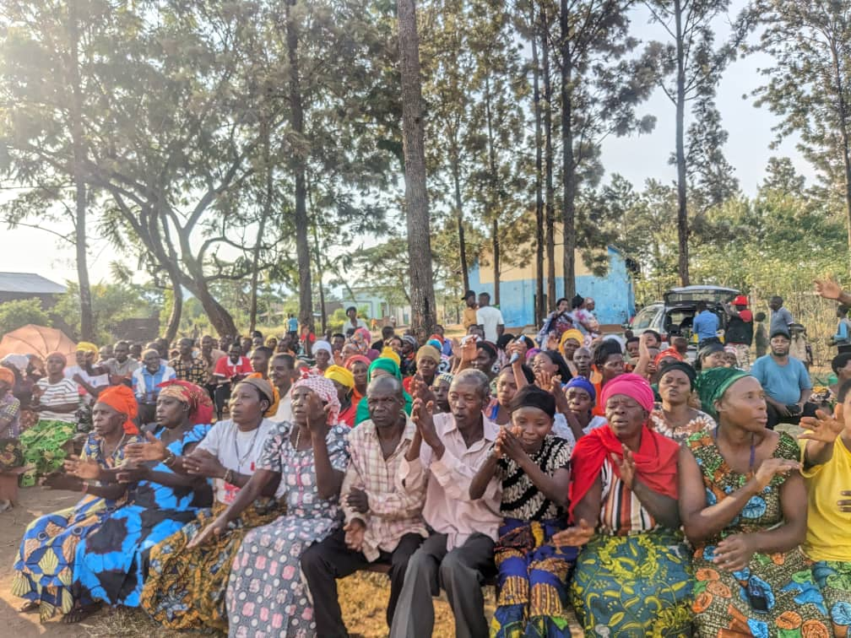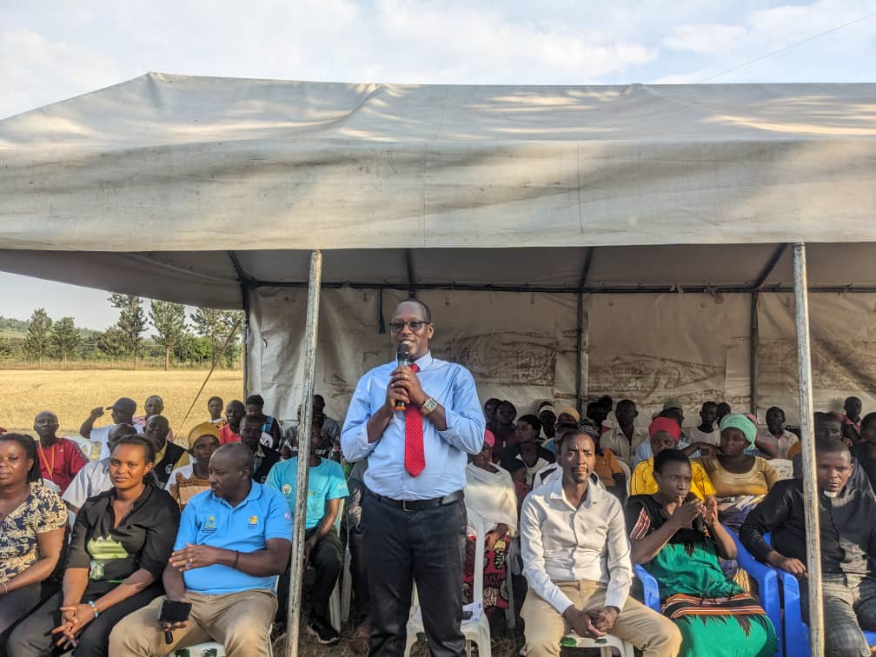

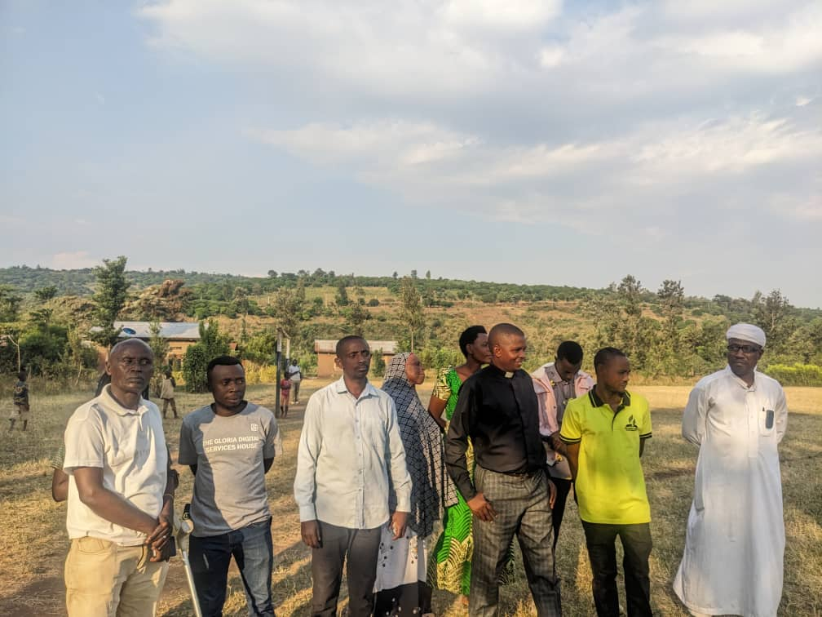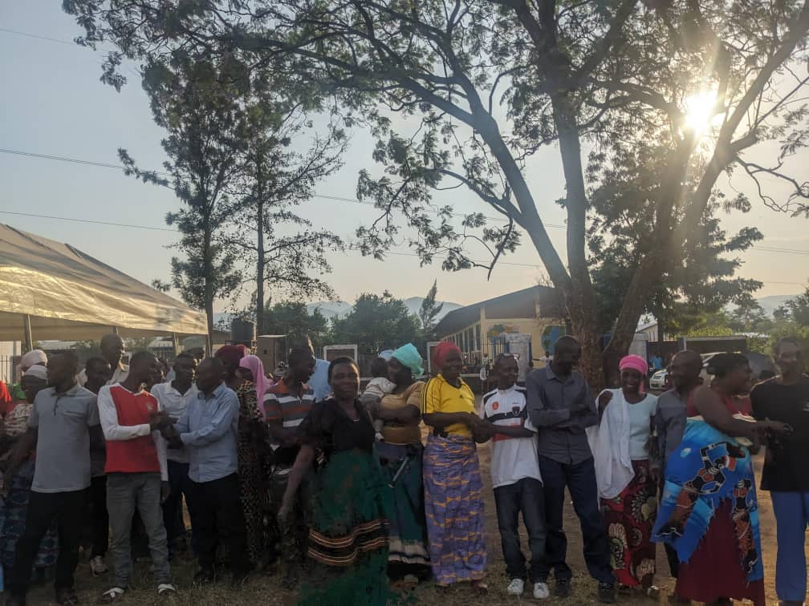

**Activity 5: Support the poor families in income generating activities.**

The 90 rabbits have been distributed to 30 vulnerable families who are the direct beneficiaries The distribution of rabbit and veterinary product has been done by the USADEC staff in collaboration with the local authorities, including the executive secretaries of the cells as well as the village committees.

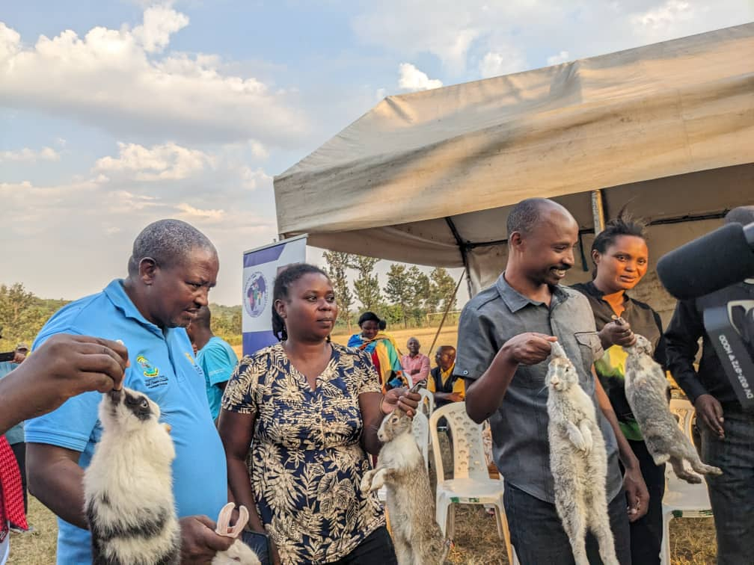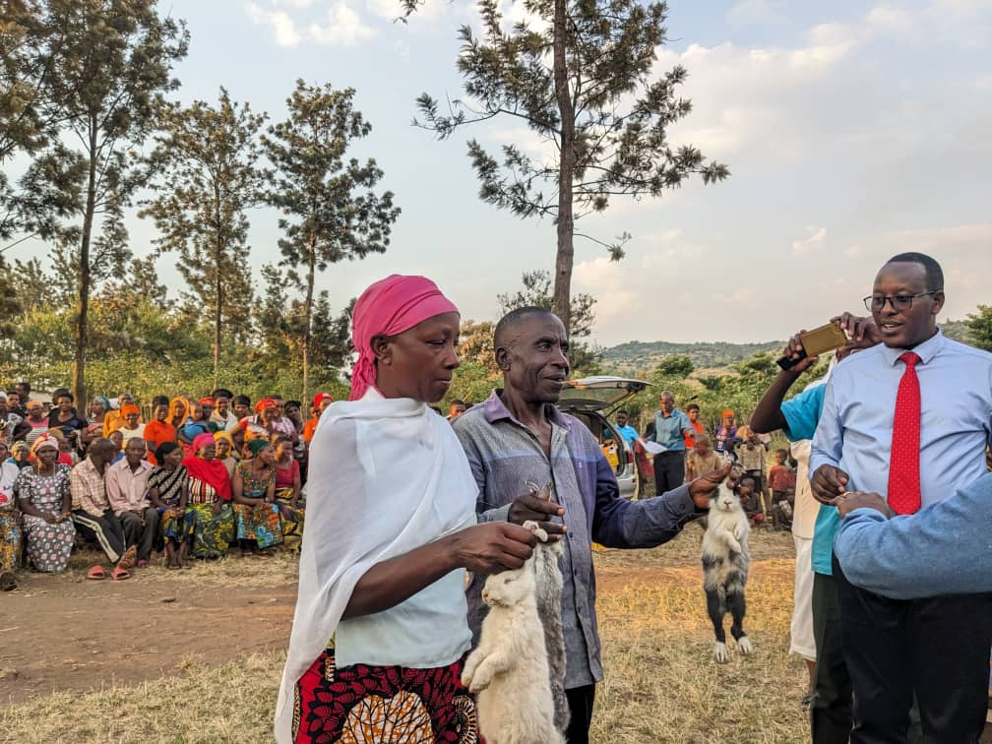

**GENDER MAINSTREAMING**

Gender Mainstreaming into interventions is USADEC's mission-based approach. In the implementation of the activities of the first milestone of the project women and men participated equally without any discrimination with respect for human rights and dignity: in KAP baseline survey 24 men and 21 women were questioned and the results were satisfactory, in the restitution meeting of the results from the KAP baseline survey among 15 Stakeholders 9 men and 6 women took part in the meeting while in the training 6 women, 3 men and 3 people l with disabilities were trained on family conflict prevention. Especially women and girls were strongly encouraged to participate actively in all Project activities this is because gender relations are power relations and some women and men may resist the change. Particular attention was be paid to issues of equality, equity and gender during all phases of the project activities Since most often women and children are victims of family conflicts, gender mainstreaming played a key role in achieving the results. During the survey, women provided in-depth information on the key causes and consequences linked to family conflicts and the 2 days meeting of the presentation of the results from KAP survey Women contributed to the formulation of strategies allowing the prevention and resolution of family conflicts. As women are part of the community animators as agents of peace and trainers on the elimination of family conflicts it is expected that the related results will be more tangible at the end of the project.

Likewise, out of 390 participants in community dialogues, including 140 women, 200 men, 40 youth and 10 local authorities were present

**SOCIAL INCLUSION**

This action was based on the promotion of the socio-economic and cultural right provided for in the Rwandan constitution and in various laws erected particularly for the protection of the rights of vulnerable peoples persons with disabilities, historically marginalized, children ,youth and women and the fight against all forms of violence committed against them. In the project implementation, everything has been done to safeguard the fundamental rights of vulnerable group. The strategies adopted for changing the mentality and attitudes of the target groups employ participatory and interactive methods.

In the KAP baseline survey 21 women against 24 men were interviewed including , representative of National council of youth and women at local level, representative of people with disability community (women, men ,people with disability) are interviewed .In the meeting with stakeholders to present the results from survey CNF, CNJ,NCPW as well as the representative of the national children's council at sector level participated in the meeting .During the training of 12 persons 6 women and 3 people with disability participated in the workshop because women, children, people with disabilities are the groups most confronted with the problems of family conflicts and their consequences, which is why they are integrated into project activities to participate in the formulation of solutions and strategies aiming at eliminate family conflict and to achieve inclusive results.

**LESSONS LEARNT** **AND OPPORTUNITIES**

Through The results of KAP Baseline survey is clear that in BUGARAMA Sector prevails a big number of cases of family conflict :3-5 cases of acute family conflict in average per each village .The key Causes of family conflictidentified are based on drunkenness/alcoholism, infidelity between spouses, inequality in the management of domestic economic resources, lack of responsibility, lack of respect between spouses, poor interpretation and understanding of the concept Gender equality and gender equity, acute poverty

The Consequences of family conflict focus on Child delinquency, children dropping out of: school, poverty, child malnutrition, killings and between spouses, suicide, depreciation, conception of early pregnancies among young girls and drug use among boys

The stakeholders are committed to become more involved in the prevention and resolution of family conflicts .They have developed and validated a joint action plan aiming at the prevention and resolution of family conflicts and they committed to implementing this action plan which will be evaluated at the end of July 2024 .They are also committed to integrating into their interventions the prevention and resolution of family conflicts with active participation of the community . Local authorities also engaged to strengthen the civic participation in the prevention and resolution of family conflicts through existing mechanisms such as UMUGANDA, UMUGOROBA W'UMURYANGO, INTEKO Y'ABATURAGE at village level

The trained community animators have agreed to be agents and catalysts of prevention and resolution of family conflicts prevention and resolution in their respective communities /Village, ISIBO through training of their peers and Mobilization in collaboration with local authorities and other stakeholders

Religious leaders constitute key actors in the prevention and resolution of family conflicts once they integrate this task into their interventions

The prevention and resolution of family conflicts concerns all actors at local level conflict prevention and resolution: family members (husbands, wives, children), local authorities of isibo, village and cell, opinion leaders, security institutions/police, RIB, organization of religious society, entire community and entire community which requires continuous and regular coordination

The Strategies for preventing and resolving family conflict focus on capacity building (training), sensitization and community mobilization ,fighting against domestic violence , providing information in time to denounce families in conflict, close Community education on family conflict, preservation of laws governing the cohabitation of spouses, socio-economic support for households socio-economic support for vulnerable households at high risk of family conflicts

## CHALLENGES AND MITIGATION MEASURES

The activities of the first milestone of the project were well executed and the local authorities and population actively participated in the implementation

Below some challenges encountered The budget allocated to the implementation of activities has been de -owned compared to the current prices of services on the market, namely car rental/ (the fuel price is expensive , the lunch ,of participants in the training and meeting , rental of conference hall for training and meeting cost for Media and mission fees for the project staff

# To the mitigate to this challenges we have proceeded to rent less comfortable conference hall and rental of transport vehicles at local level

# **CONCLUSION AND OUTLOOK**

In view of the survey results from KAP Baseline survey conducted in BUGARAMA Sector to the prevention and resolution of family conflicts in BUGARAMA, USADEC recommends all partners and institutions working for socio-economic development in BUGARAMA sector the following elements :

* They would integrate into their interventions the prevention and peaceful resolution of family conflicts because family conflict constitutes an key factor of poverty and poverty leads to violence and family conflict
* They would implement a joint action plan developed and validated aiming at prevention and resolution of family conflicts as well as its regular monitoring and evaluation to achieve the most tangible results
* Local authorities are strongly recommended to initiate the community to take ownership of the family conflict prevention and resolution process
* The mechanisms already in place granting space to the community such as UMUGANDA, INTEKO Z’ABATURAGE and UMUGOROBA W’UMURYANGO should be more exploited for the prevention and resolution of family conflicts
* The IZU (INSHUTI Z’UMURYANGO) deserve the specific capacity building to be more operational and efficient
* Vulnerable families should benefit from socio-economic support to avoid the potential risk of family conflict
* Victims households of family conflict deserve specific support for their rehabilitation and healing of hearts
* Recruitment and training of animators for healing hearts are very needed
* Spouses who cohabit illegally should be educated to enter into legal marriage
* The causes and consequences of family conflicts in BUGARAMA Sector, are highlighted and the families in conflict have already been identified and located, Thus, the role of everyone proves necessary to proceed with the elimination of family conflicts

**Done at Kigali on July 10, 2024**

**MAHORO RUBIBI Alexis**

**Executive Director of USADEC**

